WELCOME
OCTOBER
18th 2020

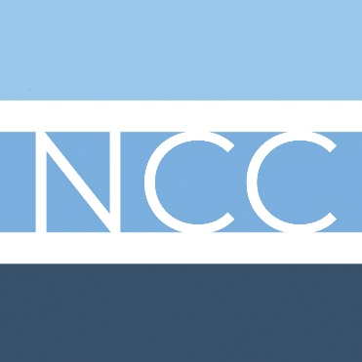
New Creation Church

November
29th, 2020
9:30am

ALL FAMILY SUNDAY

WELCOME to New Creation Church! Our prayer is that you feel welcome, loved, and comfortable worshiping with us. We are so happy you’re here! Pastor Keith loves to connect in person, he loves coffee, and he loves to walk/hike. If you’d like to join him just text or call him at (615) 854-5209.
Happening at New Creation
- Soup’er Tuesday: Bacon Cheeseburger, Chicken w/White Beans and Kale, 11:30-1:00
- No Services: December 27th
- Fill out your ‘Pineapple Card’

Safe Service Sundays at 8:30 am
- masks at all times
- no donuts
- no childcare
- extended social distancing
- no singing

- FFill this out to get an adult long-sleeved t-shirt, $15.00
Name: ______________________________________
Sizes: ___________________________________
(Tear this off and put in the basket!)

Order of Worship
Gathering Song
Call to Worship
Advent Reading and Lighting
Song
Announcements
Community Connection

Community Prayer
Christmas Singing
Message
Closing Song
**Baptism of Ryan Stephens
Benediction (@ Sea Star in Hendersonville)
We will meet at NOON at Sea Star for Ryan’s Baptism.
127 Sanders Ferry Road, Hendersonville, 38075

Events and Dates to Remember:

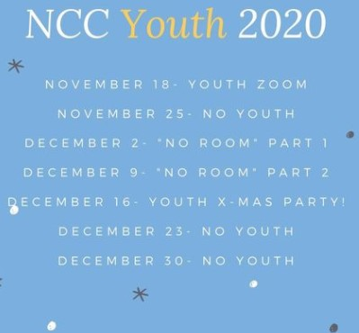
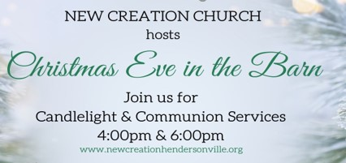

Keeping You Informed…

‘Christmas For Families Tree’ is Here!
Starting this week, you have the opportunity to pick items to purchase for 3 local families in need of a little help this Christmas Season. Simply sign out the item you will shop for and return the gift to the church wrapped and labeled with the ornament you picked that goes with the gift.

Congregational Meeting
December 6th 9:50 a.m. we will have a congregational meeting prior to the 10 a.m. worship service.
Ways to Give
- Text to GIVE. You can now text (615)505-4230 with the message “GIVE.” It will walk you through what to do next.
- Please go to your Kroger App and add us to your Community Rewards.
- We have VENMO: @New-Creation-Hville
- Put it in the basket up at the front.

New Creation Church Staff
Pastor: Keith Gunter
keithgunter@newcreationhendersonville.org
Children and Youth Director: John Radzimanowski
john@newcreationhendersonville.org
Ministry Coordinator: Michelle Salada
msalada@newcreationhendersonville.org
Children’s Coordinator: Kelly Roche kroche1587@gmail.com

Notes:

New Creation Church
1020 Avondale Road Suite 103 & 106
Hendersonville TN 37075
Website: www.newcreationhendersonville.org

